Sprint 4 Plan

Product Name : UpToDate

Team Name: UpToDaters

Release Name : UpToDate

Release Date : 3/19/18

Revision Number : 1

Revision Date : 3/4/18

Goal: Cleanup and bug hunt

Task Listing

* User Story 1: As a developer, I want to add a ui trending slide (3 points)
  + Task 1: Fetch database items (2 hours)
  + Task 2: Display with javascript (30 minutes)
* User Story 2: As a user, I want an archive page to see past searches (5 points)
  + Task 1: Fetch past results from the database (2 hours)
  + Task 2: Display all past results (30 minutes)
* User Story 3: As a user, I want a user friendly and bug free ui (8 points)
  + Task 1: Better user flow (1 hours)
  + Task 2: Pictures (2 hours)
  + Task 3: Color Changes and better color flow (1 hour)
* User Story 4: As a developer, I want to have a nicer master git branch. (3 points)
  + Task 1: Delete Unnecessary branches (3 hours)
  + Task 2: Merge into one branch (4 hours)

Team Roles

* Team Member Manav Sharma: Product Owner
* Team Member Tariq Anees: Developer
* Team Member Andrew Boyadjiev: Developer
* Team Member Arthur Kung: Developer
* Team Member Tommy Tran: Scrum Master
* Team Member Vanessa Tan: Developer

Initial Task Assignment

* Team Member Manav Sharma will work on user story 3
* Team Member Tariq Anees will work on user story 2
* Team Member Andrew Boyadjiev will work on user story 1
* Team Member Arthur Kung will work on user story 4
* Team Member Tommy Tran will work on user story 4
* Team Member Vanessa Tan will work on user story 2

Burn Up Chart

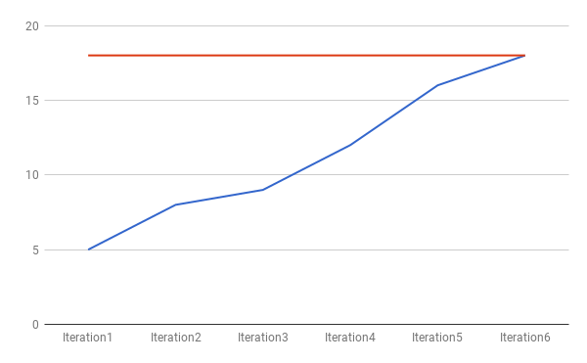

Scrum Times

* Monday at 11:30 am (TA visit)
* Wednesday at 9:00 am
* Friday at 9:00 am

Scrum Board

